Assignment Questions on Digital Marketing

KIRUTHIKA R

FINAL YEAR

BIOMEDICAL ENGINEERING

GNANAMANI COLLEGE OF TECHNOLOGY

1.Create a blog or website using Blogspot and WordPress. Customize the theme design and post new article with 500 words.

<https://kiruthikaram.blogspot.com/2023/10/carry-eco-friend.html>

2.Create a New Facebook Business Page and post one social media poster for your brand.

<https://www.facebook.com/profile.php?id=61552710269632&mibextid=ZbWKwL>

3.Create and design a social media advertisement poster using canva.

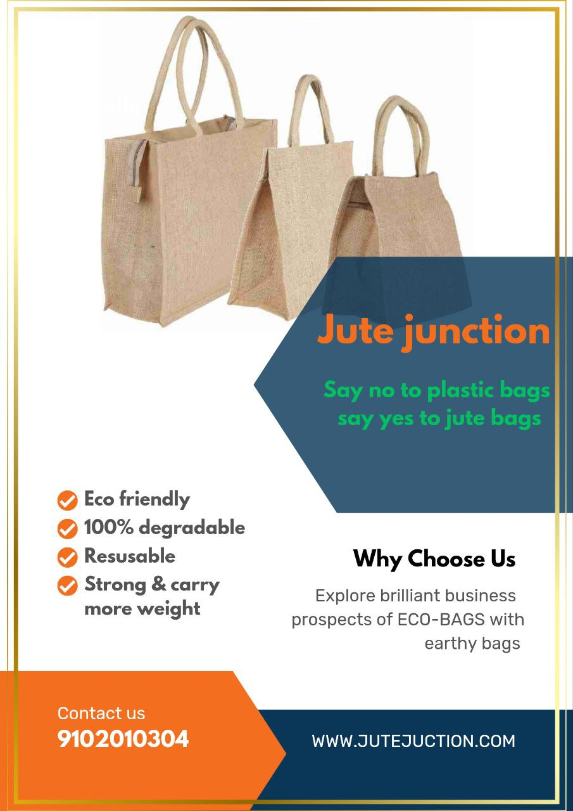

4.Create email newsletter design using Mail Chimp or canva tool.

